 ECEWS CDC SPEED PROJECT

**PROPOSAL FOR** **PURCHASE OF POWER POINT PRESENTATION TEMPLATE**

**Date submitted: 05 December 2023**

**Dates of Activity: 05 December 2023**

|  |  |  |
| --- | --- | --- |
| **1** | **Approved Quarter** | Quarter 1 of FY 24 |
| **2** | **State** | FCT, |
| **3** | **Facilities Involved** | SPEED project supported States |
| **4** | **Background** | Using high-quality presentation templates will elevate the overall aesthetic of our presentations. This, in turn, will contribute to a more professional image for our organization, making a positive impression on clients, stakeholders, and internal teams.  Professional templates ensure consistency in our visual communication. By adhering to a standardized template, we can reinforce our brand identity, making our presentations instantly recognizable and reinforcing a sense of cohesion across various departments.  These templates are designed to be user-friendly, allowing our team to create visually appealing presentations efficiently. The pre-designed layouts and elements will save valuable time, enabling us to focus more on the content and strategic aspects of our presentations |
| **5** | **Objectives/Deliverables** | * Purchase of power point presentation template for SPPED project |
| **6** | **Expected Outcome** | * Quality presentation for all out meetings |
| **7** | **Follow-up Plan** | Continue maintenance to ensure the instance is running optimally |
| **8** | **ECEWS Participant** | Health informatics team |
| **9** | **Total amount Budgeted and budget line No.** | **N70,000** |
| **10** | **Recommendation** |  |
| **11** | **Remarks/Comments** | Activity aligns with project objectives as it will enhance cooperation and resource leveraging among implementing partners in the state |
| **12** | **Approval** |  |



ECEWS CDC SPEED PROJECT

TECHNICAL AREA (BUDGET LINE): Development of Dashboard & Synch Service

TECHNICAL AREA (BUDGET CODE): MEL009

In accordance with the approved budget lines, I hereby request the sum of

(Amount in Figures): **N 70,000**

(Amount in words): **Seventy-thousand Naira Only.**

**PURPOSE:** Purchase of Power Point Template

**Name of Applicant**: Temiye Oluseun (User department): Health Informatics Strategic Information

Signature:  Date: 05 December 2023.

|  |  |  |  |  |  |
| --- | --- | --- | --- | --- | --- |
| **System specification** | **Unit Cost** | **No of users** | **months** | **Total** | **Option** |
| Power point presentation template | 70,000 | 1 | 12 | 70,000 | On time payment |
|  | **Total** |  |  | **N70,000** |  |

RECOMMENDED BY: Abutu Inedu 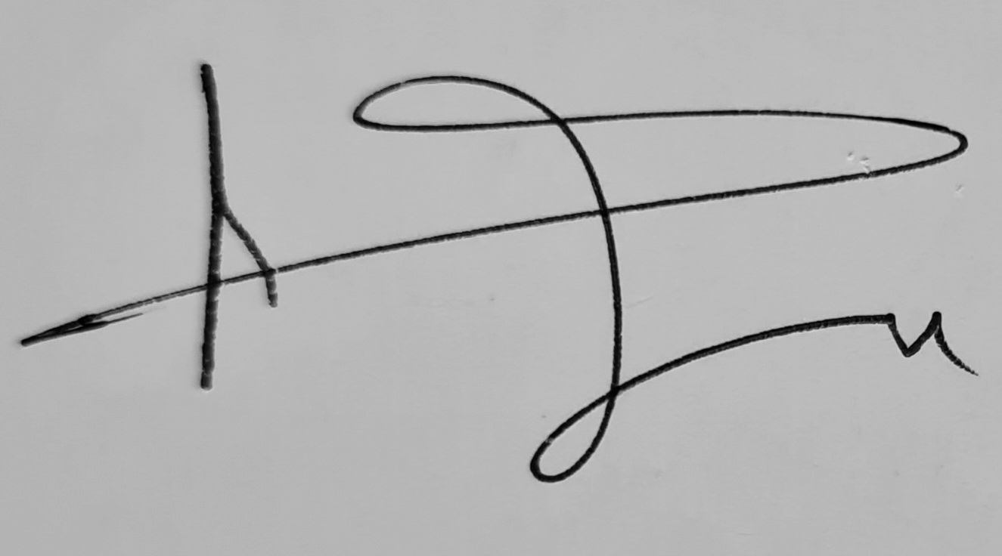

REVIEWED BY: ____________________________________________________________

**